Computer Architecture Lab
(EL-2012)
LABORATORY REPORT

Fall 2026

(Lab#02)
Write Lab Title Here

Student Name: Muhammad Hamza Roll No: 24i-6513 Section: A

Date performed: 02 , Sep , 2026

MARKS AWARDED: ________ / 10

Signature and date of Instructor: _________________
Lab Instructors: Dr. Nasir Ali Shah, Engr. Fasih Ahmad

______________________________________________________________________________________________________________________________________________________

NATIONAL UNIVERSITY OF COMPUTER AND EMERGING SCIENCES, ISLAMABAD
Prepared by: | Fasih Ahmad |  | Version: 1.0
Verified by: | Dr. Nasir Ali Shah |  | Updated: Fall 2026

Task 1:

Description:
// Write description of the task here 👇 (max. five to seven lines)
In this task we created half adder using different level of abstraction like using (Gate Level modeling , Dataflow Level modeling and Behavioral modeling) and learned how this design are different from each other.

Code:
//Half Adder Gate Level Modeling  module Half_Adder(a, b , s , c);  input a , b;  output s , c;  and a1(c , a, b);  xor x1(s , a , b);  endmodule  module testbench();  wire sum , carry;  reg in1 ;  reg in2 ;  Half_Adder uut(in1, in2 , sum , carry);  initial  begin  in1= 0 ; in2 = 0;  #50;  in1= 0 ; in2 = 1;  #50;  in1= 1 ; in2 = 0;  #50;  in1= 1 ; in2 = 1;  #50;  end  endmodule | //Half Adder Date Flow Level modeling  module Half_Adder(A , B , S , C);  input A , B;  output S , C;  assign S = A^B;  assign C = A&B;  endmodule  module TestBench_Half_Adder();  reg in1 , in2 ;  wire sum , carry;  Half_Adder hd(in1 ,in2 , sum ,carry);  integer i;  initial begin  for (i = 0 ; i < 4 ;i = i+1) begin  {in1 , in2}= i;  #50;  end  end  endmodule | // Behavioral Level modeling  module Half_Adder(A , B , S , C);  input A , B;  output reg S , C;  always @(A or B)  begin  S = A^B;  C = A&B;  end  endmodule // how are you  module TestBench_Half_Adder_Behavioral();  reg in1 , in2 ;  wire sum , carry;  Half_Adder hd(in1 ,in2 , sum ,carry);  integer i;  initial begin  for (i = 0 ; i < 4 ;i = i+1) begin  {in1 , in2}= i;  #50;  end  end  endmodule
// Gate level model of full adder  module Half_Adder(a, b , s , c);  input a , b;  output s , c;  and a1(c , a, b);  xor x1(s , a , b);  endmodule  module Full_Adder(x , y , cin , sum , carry) ;  input x , y , cin;  output sum , carry;  wire t1 , t2 , t3 ;  Half_Adder h1 (x, y , t1 , t2);  Half_Adder h2(t1 , cin , sum , t3);  or (carry , t3 , t2);  endmodule  module testbench();  wire sum , carry;  reg in1 , in2 , in3;  Full_Adder uut(in1, in2 , in3 , sum , carry);  initial  begin  in1= 0 ; in2 = 0; in3 =0;  #50;  in1= 0 ; in2 = 0; in3 =1;  #50;  in1= 0 ; in2 = 1; in3 =0;  #50;  in1= 0 ; in2 = 1; in3 =1;  #50;  in1= 1 ; in2 = 0; in3 =0;  #50;  in1= 1 ; in2 = 0; in3 =1;  #50;  in1= 1 ; in2 = 1; in3 =0;  #50;  in1= 1 ; in2 = 1; in3 =1;  #50;  end  endmodule | // Data Flow Modeling of Full Adder  module Half_Adder(a, b , s , c);  input a , b;  output reg s , c;  assign s = a^b;  assign c = a&b;  endmodule  module Full_Adder(x , y , cin , sum , carry) ;  input x , y , cin;  output sum , carry;  wire t1 , t2 , t3 ;  Half_Adder h1 (x, y , t1 , t2);  Half_Adder h2(t1 , cin , sum , t3);  assign carry = t3 | t2;  endmodule  module testbench_FullAdder_Dataflow();  wire sum , carry;  reg in1 , in2 , in3;  Full_Adder uut(in1, in2 , in3 , sum , carry);  integer i;  initial  begin  for (i = 0 ;i < 8 ; i= i+1) begin  {in1 , in2 , in3 } = i;  #50;  end  end  endmodule | // Behavioral Modeling  module Full_Adder(x , y , cin , sum , carry) ;  input x , y , cin;  output reg sum , carry;  always @(*)  begin  if (x == 0 && y ==0 && cin == 0) begin sum =0 ; carry = 0; end  else if (x == 0 && y ==0 && cin == 1) begin sum =1 ; carry = 0; end  else if (x == 0 && y ==1 && cin == 0) begin sum =1 ; carry = 0; end  else if (x == 0 && y ==1 && cin == 1) begin sum =0 ; carry = 1; end  else if (x == 1 && y ==0 && cin == 0) begin sum =1 ; carry = 0; end  else if (x == 1 && y ==0 && cin == 1) begin sum =0 ; carry = 1; end  else if (x == 1 && y ==1 && cin == 0) begin sum =0 ; carry = 1; end  else begin sum =1 ; carry = 1; end  end  endmodule  module testbench_FullAdder_Behavioral();  wire sum , carry;  reg in1 , in2 , in3;  Full_Adder uut(in1, in2 , in3 , sum , carry);  integer i;  initial  begin  for (i = 0 ;i < 8 ; i= i+1) begin  {in1 , in2 , in3 } = i;  #50;  end  end  endmodule

Output:
Logism
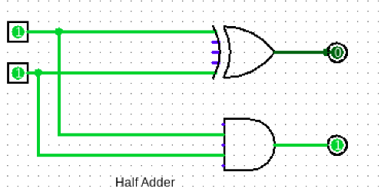

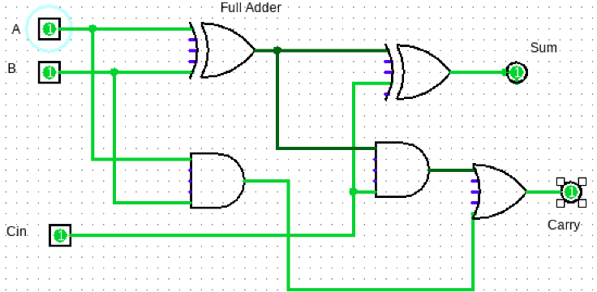

Half_Adder data flow
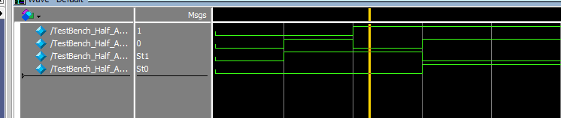

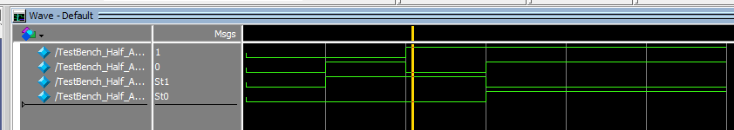
Half adder Behavioral modeling

Full Adder Data flow
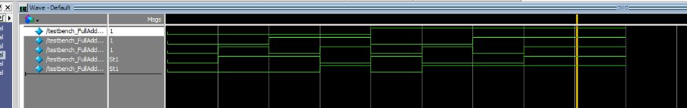
Full adder Behavioral
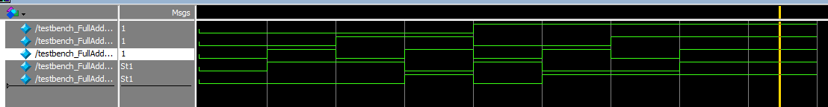

Task 2:

Description:
// Write description of the task here 👇 (max. five to seven lines)
In this task I made a 3x8 decoder and it’s quit easy in the model sim. We used different approaches to design it like gate level and data flow level modeling.
Code:
// Paste source code here 👇
// 3x8 Decoder using Gate level modeling  module Decoder(s0, s1, s2, D0, D1, D2, D3, D4, D5, D6, D7);  input s0, s1, s2;  output D0, D1, D2, D3, D4, D5, D6, D7;  wire inv0, inv1, inv2;  not (inv0, s0);  not (inv1, s1);  not (inv2, s2);  and (D0, inv0, inv1, inv2);  and (D1, inv0, inv1, s2);  and (D2, inv0, s1, inv2);  and (D3, inv0, s1, s2);  and (D4, s0, inv1, inv2);  and (D5, s0, inv1, s2);  and (D6, s0, s1, inv2);  and (D7, s0, s1, s2);  endmodule  module testbench_3x8Decoder();  reg in1 , in2 , in3;  wire d0 , d1 , d2 , d3 , d4 , d5 , d6 , d7;  Decoder uut(in1, in2 , in3 , d0 , d1 , d2 , d3 , d4 , d5 , d6 , d7);  initial  begin  in1= 0 ; in2 = 0; in3 =0;  #50  in1= 0 ; in2 = 0; in3 =1;  #50  in1= 0 ; in2 = 1; in3 =0;  #50  in1= 0 ; in2 = 1; in3 =1;  #50  in1= 1 ; in2 = 0; in3 =0;  #50  in1= 1 ; in2 = 0; in3 =1;  #50  in1= 1 ; in2 = 1; in3 =0;  #50  in1= 1 ; in2 = 1; in3 =1;  end  endmodule | // 3x8 Decoder using Data flow model  module Decoder(s0, s1, s2, D0, D1, D2, D3, D4, D5, D6, D7);  input s0, s1, s2;  output D0, D1, D2, D3, D4, D5, D6, D7;  assign D0 = !s0 & !s1 & !s2;  assign D1 = !s0 & !s1 & s2;  assign D2 = !s0 & s1 & !s2;  assign D3 = !s0 & s1 & s2;  assign D4 = s0 & !s1 & !s2;  assign D5 = s0 & !s1 & s2;  assign D6 = s0 & s1 & !s2;  assign D7 = s0 & s1 & s2;  endmodule  module testbench_3x8Decoder_DataFlow();  reg in1 , in2 , in3;  wire d0 , d1 , d2 , d3 , d4 , d5 , d6 , d7;  Decoder uut(in1, in2 , in3 , d0 , d1 , d2 , d3 , d4 , d5 , d6 , d7);  initial  begin  in1= 0 ; in2 = 0; in3 =0;  #50;  in1= 0 ; in2 = 0; in3 =1;  #50;  in1= 0 ; in2 = 1; in3 =0;  #50;  in1= 0 ; in2 = 1; in3 =1;  #50;  in1= 1 ; in2 = 0; in3 =0;  #50;  in1= 1 ; in2 = 0; in3 =1;  #50;  in1= 1 ; in2 = 1; in3 =0;  #50;  in1= 1 ; in2 = 1; in3 =1;  end  endmodule

Output:
// Import output here 👇
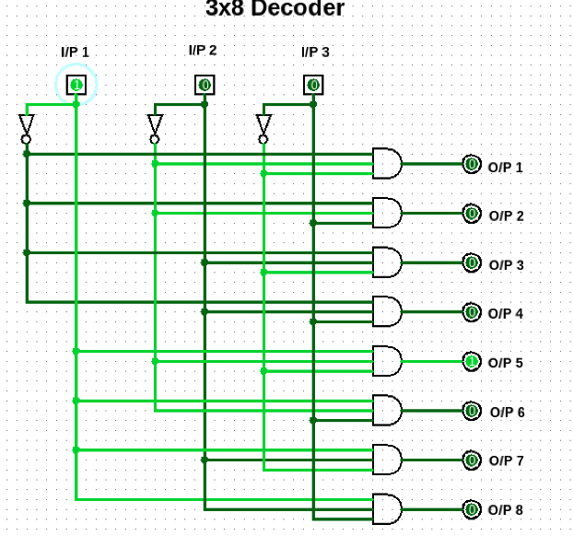
Gate Level Modeling
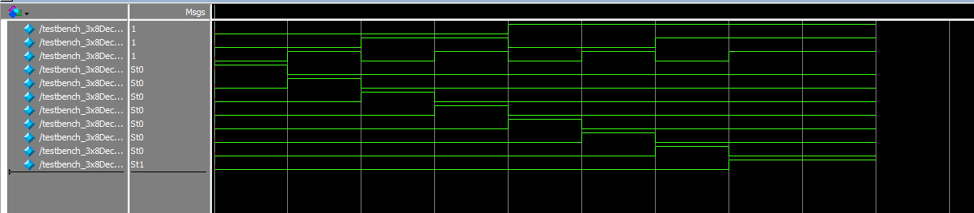

Dataflow modeling
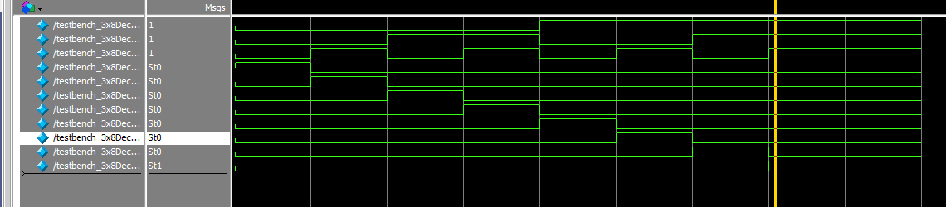

Task 3:

Description:
// Write description of the task here 👇 (max. five to seven lines)
In this task I made a 8to1 Mux which is basically a selector we have the choice to select the input by using the select lines so we made it by two method the gate level and data flow level modeling.

Code:
// Paste source code here 👇  module MUX_8to1 ( s0, s1, s2,i0, i1, i2, i3, i4, i5, i6, i7, out);  input s0 , s1 , s2;  input i0, i1, i2, i3, i4, i5, i6, i7;  output out;  wire inv0, inv1, inv2;  not (inv0, s0);  not (inv1, s1);  not (inv2, s2);  wire D0, D1, D2, D3, D4, D5, D6, D7;  and (D0, i0, inv0, inv1, inv2); // 000  and (D1, i1, inv0, inv1, s2); // 001  and (D2, i2, inv0, s1, inv2); // 010  and (D3, i3, inv0, s1, s2); // 011  and (D4, i4, s0, inv1, inv2); // 100  and (D5, i5, s0, inv1, s2); // 101  and (D6, i6, s0, s1, inv2); // 110  and (D7, i7, s0, s1, s2); // 111  or (out, D0, D1, D2, D3, D4, D5, D6, D7);  endmodule  module TestBench_MuxGatelevel();  reg s0, s1 ,s2;  reg i0, i1, i2, i3, i4, i5, i6, i7;  wire Y;  MUX_8to1 uut(s0,s1,s2 , i0, i1, i2, i3, i4, i5, i6, i7 , Y);  integer i;  initial  begin  i0 = 0;  i1 = 1;  i2 = 0;  i3 = 1;  i4 = 0;  i5 = 1;  i6 = 0;  i7 = 1;  for (i =0 ;i < 8; i = i+1)  begin  {s0 , s1 ,s2 } = i;  #50;  end  end  endmodule | // Data flow model  module MUX_8to1 ( s0, s1, s2,i0, i1, i2, i3, i4, i5, i6, i7, out);  input s0 , s1 , s2;  input i0, i1, i2, i3, i4, i5, i6, i7;  output out;  assign out = (i0 & !s0 & !s1 & !s2) |  (i1 & !s0 & !s1 & s2) |  (i2 & !s0 & s1 & !s2) |  (i3 & !s0 & s1 & s2) |  (i4 & s0 & !s1 & !s2) |  (i5 & s0 & !s1 & s2) |  (i6 & s0 & s1 & !s2) |  (i7 & s0 & s1 & s2);  endmodule  module TestBench_MuxDataflow();  reg s0, s1 ,s2;  reg i0, i1, i2, i3, i4, i5, i6, i7;  wire Y;  MUX_8to1 uut(s0,s1,s2 , i0, i1, i2, i3, i4, i5, i6, i7 , Y);  integer i;  initial  begin  i0 = 0;  i1 = 1;  i2 = 0;  i3 = 1;  i4 = 0;  i5 = 1;  i6 = 0;  i7 = 1;  for (i =0 ;i < 8; i = i+1)  begin  {s0 , s1 ,s2 } = i;  #50;  end  end  endmodule
Output:
// Import output here 👇
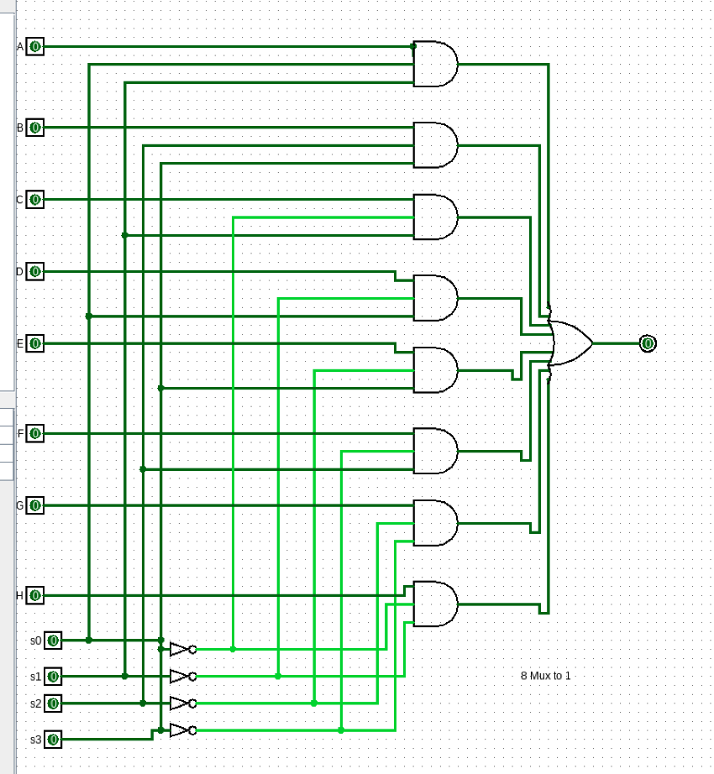
Gatelevel Model
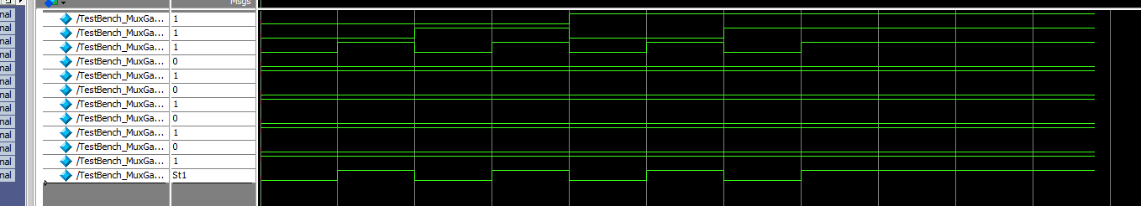

Dateflow model
